--=================================================================================

--===============================CIS 310 ASSIGNMENT 4===============================

--=================================================================================

/**Remember to fill out below section AND reflecting your name in file name.   
Great job to those who have been consistently doing so.

STUDENT NAME: Jacob Palmer

STUDENT ID: 5262256

SUBMISSION DATE: 2/8/2024

*/

Part 1. For below PRODUCT data model, answer the following questions (10 pts)

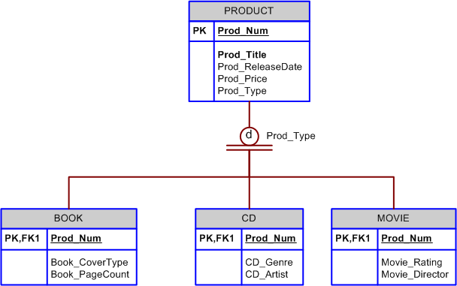

1. List all of the attributes of a movie. Remember the inheritance nature between the Supertype and Subtype entities.
   * The attributes of a movie are its rating and director, product number, product title, product release date, and product price. While product type is also an attribute, it will always be “movie” in this case
2. Is it possible for a book to appear in the BOOK table without appearing in the PRODUCT table? Why or why not?
   * As the two horizontal lines beneath the disjoint notation (A product cannot be more than one of the three at once, as opposed to overlapping) denotes total completeness constraints, every product MUST be either a book, a cd, or movie. Likewise, any of those three MUST also be considered a product

Part 2. Given the following business scenario, create a Crow’s Foot ERD using a specialization hierarchy if appropriate. (20 pts)

Granite Sales Company keeps information on employees and the departments that they work in. **For each department, the department name, internal mail box number, and office phone extension are kept**. **A department can have many assigned employees, and each employee is assigned to only one department**. **Employees can be salaried employees, hourly employees, or contract employees**. **All employees are assigned an employee number**. This is kept along with **the employee’s name and address**. **For hourly employees, hourly wage and target weekly work hours are stored** (e.g. the company may target 40 hours/week for some, 32 hours/week for others, and 20 hours/week for others). **Some salaried employees are salespeople that can earn a commission in addition to their base salary**. **For all salaried employees, the yearly salary amount is recorded in the system. For salespeople, their commission percentage on sales and commission percentage on profit are stored in the system**. For example, John is a salesperson with a base salary of $50,000 per year plus 2-percent commission on the sales price for all sales he makes plus another 5 percent of the profit on each of those sales. **For contract employees, the beginning date and end dates of their contract are stored along with the billing rate for their hours.**

--* Below hints are in font color white, **to reveal, select and change their font colors**.   
You get the best practice by **not** using the hints, or use them **after** your design, to double-check your work.

--Hint 1 on overall structure of the ERD: Can you have more than one layer of supertype subtype relationship? Yes.

--Hint 2 remember to use keys to establish the special “is a” relationship: What’s an appropriate FK that will indicate the subtypes on the supertype?

--Hint 3 the 2 dimensions of supertype subtype relationships: Do you need to have both dimensions of constraints, or could you have one without the other? Complete vs partial, and disjoint vs overlap. One is required as it establishes the supertype vs subtype dimension. But is subtype vs subtype dimension always applicable or required? Not necessarily.  
--Hint 4 How many entities should you have: Your ERD should have 6 entities.

--Hint 5 I am still stuck, what should be my first step after reading the prompt? You should have an entity of EMPLOYEE and one of DEPARTMENT, as indicated by the first 3 sentences. It establishes the normal 1:M relationship as we’ve covered in the previous chapters.

--Hint 6 What’s next? Out of the 2, EMPLOYEE and DEPARTMENT, EMPLOYEE has a list of subcategories/unique subtypes with attributes unique to each subtype. It further has one subtype within one of the first layer of 3 subtypes.